Software Design Document
Project: Health Care Management System
1. Introduction
The Healthcare Management System (HMS) is a web-based application designed to streamline hospital operations by integrating patient registration, appointment scheduling, doctor management, and medical records. This system provides role-based access for patients, doctors, and administrators to ensure smooth communication and workflow. The application enhances data accuracy, security, and accessibility for all healthcare stakeholders. It supports real-time services like e-prescriptions, billing, and report generation. This Software Design Document outlines the architecture, components, and data flow of the system.
2.Technology Stack
Frontend: React.js
Backend: Spring Boot (Java)
Database: MySQL
Tools: Postman, Swagger, GitHub, MySQL Workbench

3.Use Case Diagram
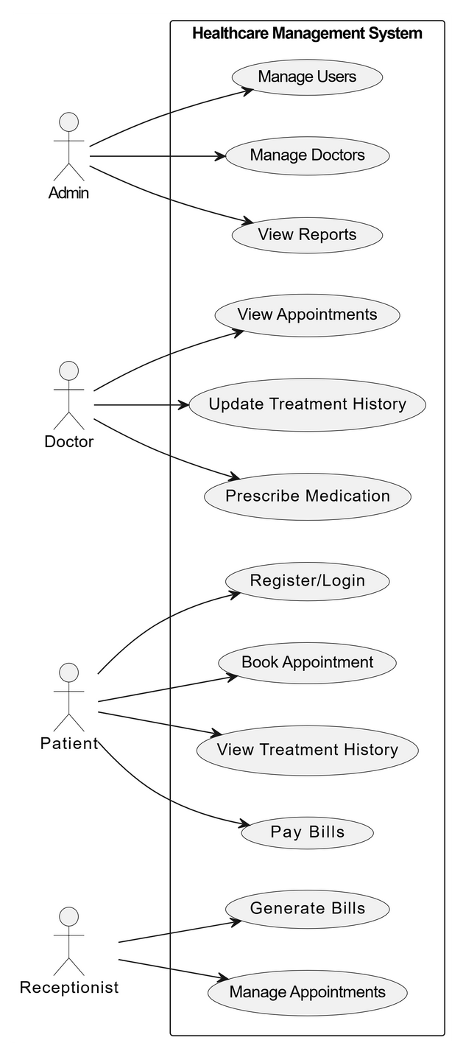

4. Entity Relationship Diagram
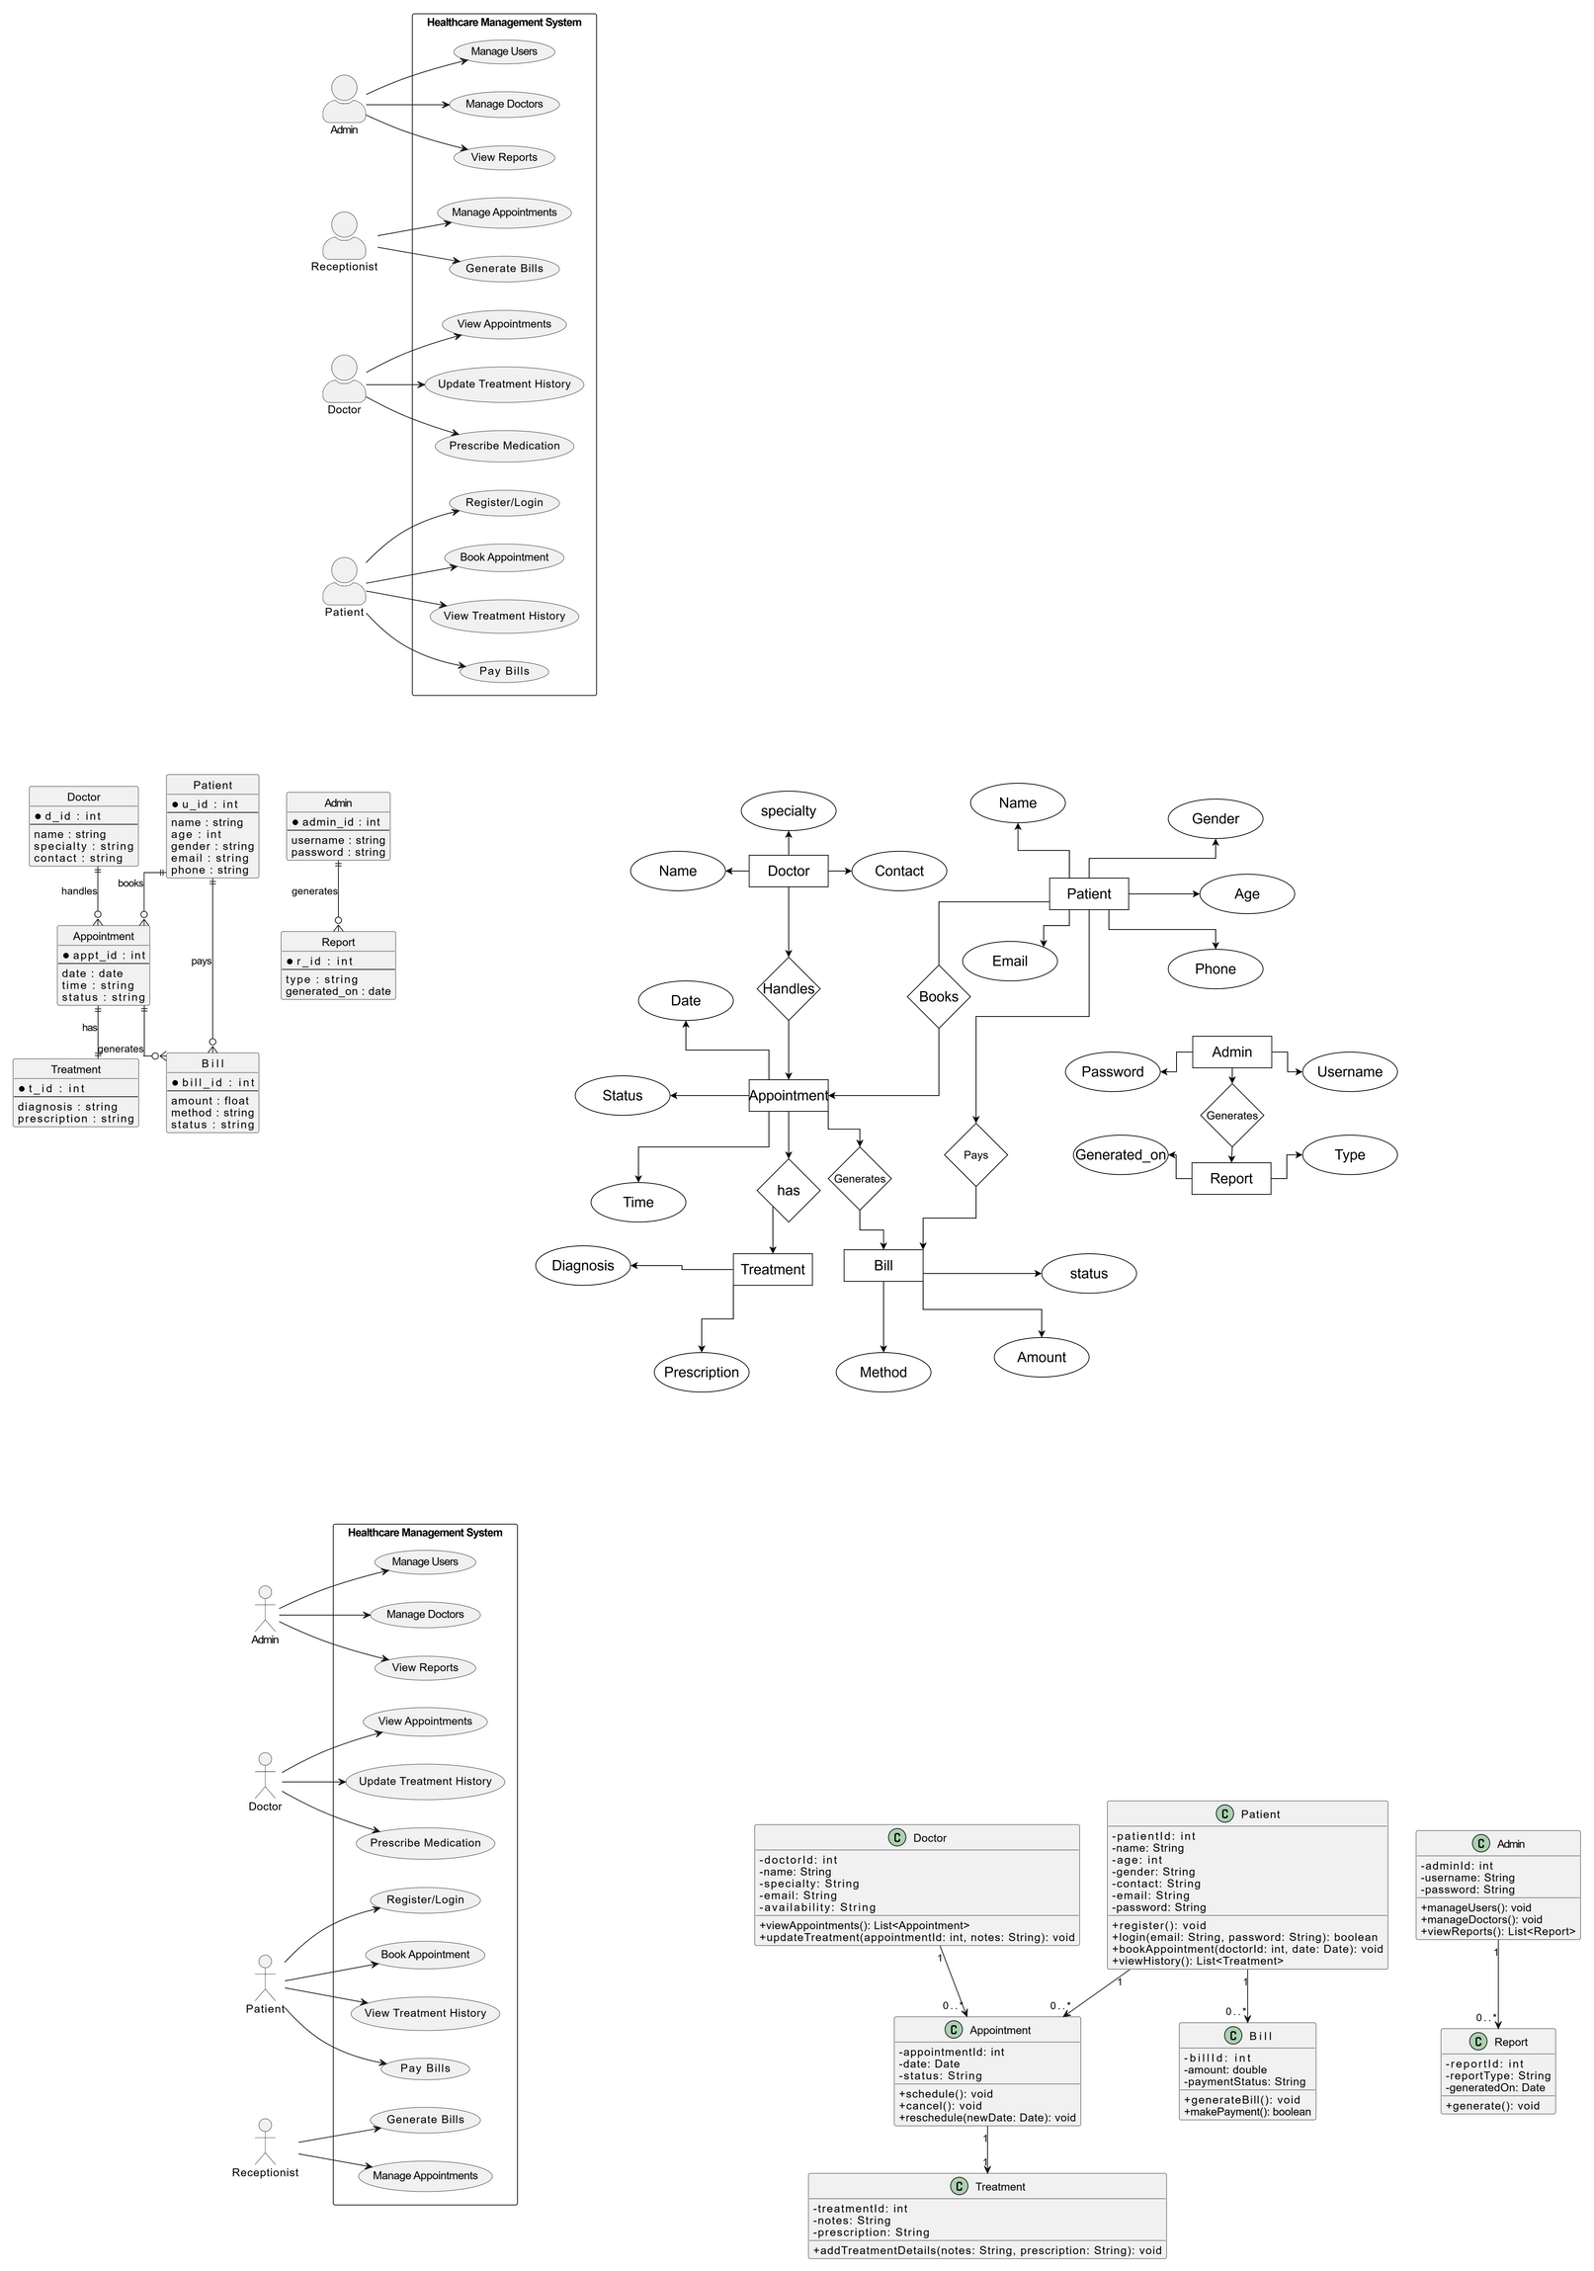

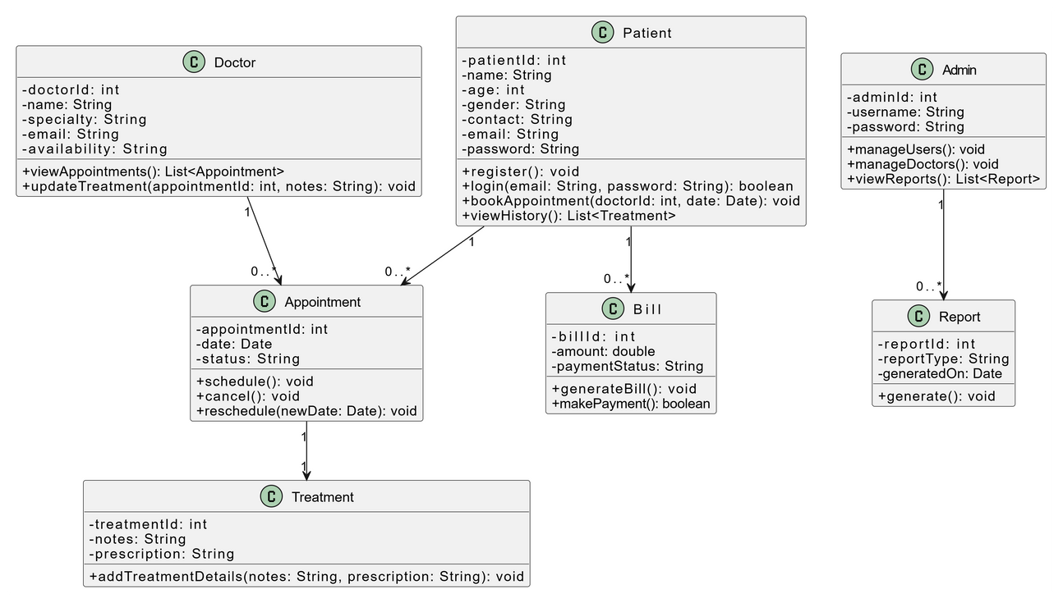
5.Class Diagram

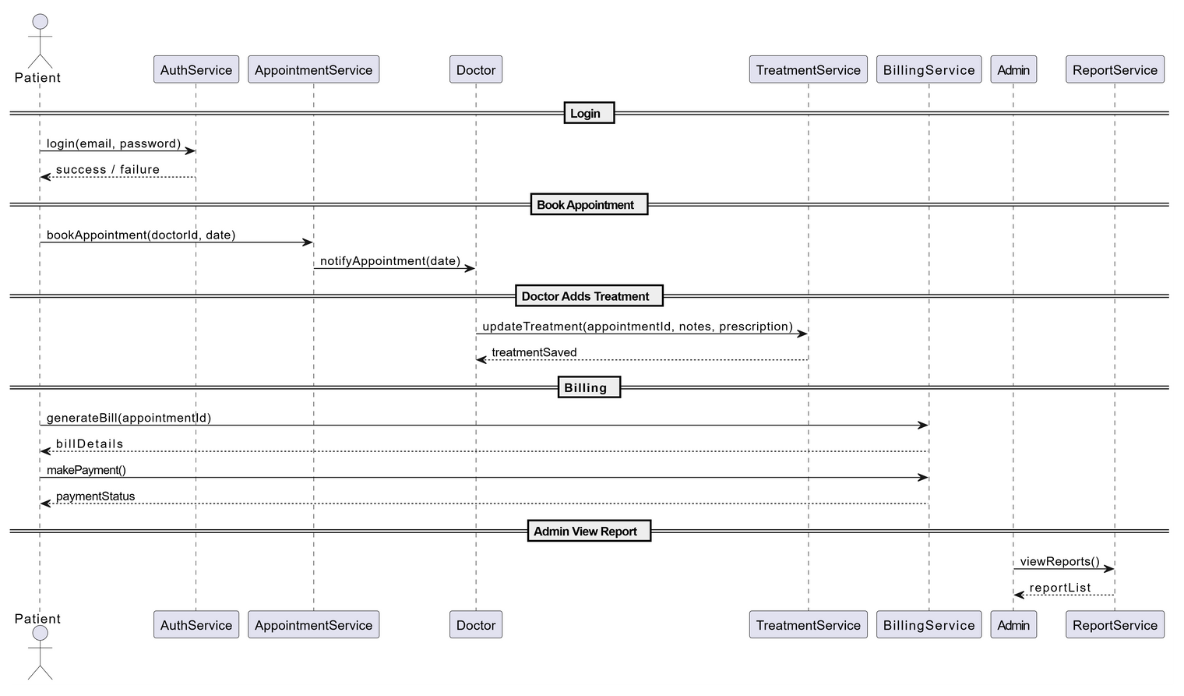
6.Sequential Diagram

7.Conclusion:
This Software Design Document provides a clear and structured design for the Healthcare Management System. It ensures secure, scalable, and efficient management of healthcare operations using React, Spring Boot, and MySQL. The design lays a solid foundation for building a user-friendly and reliable web application to streamline patient care and hospital workflows.

